Change Order Request

November 14, 2016

Chinn Construction, LLC
14715 NE 95th Street, Suite 101
Redmond, WA 98052
Attn: Charlie Poggemann

Re: Hadley Apartment Project – Change Order Request – Extend Rain Runnel Piping

Charlie,

Per direction from Chinn, OWP extended the downspout piping from the building to the rain runnel by hand digging. Total cost is $968 + 10% OH&P = $1,065. Please issue an official Change Order at your earliest convenience.

Let me know if you have any questions or comments. Thank you.

Sincerely,
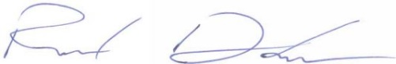
Richard Donelson
Project Manager / Estimator
LEED® Green Associate
richd@owpllc.net
425-591-4296 cell

